Name: Lane Dorscher
Date: 09/08/2025

Here are screenshots from the virtual desktop showcasing my program open in IDLE IDE.
This is my file which is saved to my desktop.
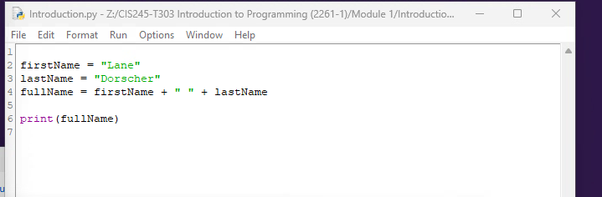

Here is the IDLE shell which has ran my simple introduction program successfully showcasing simple string concatenation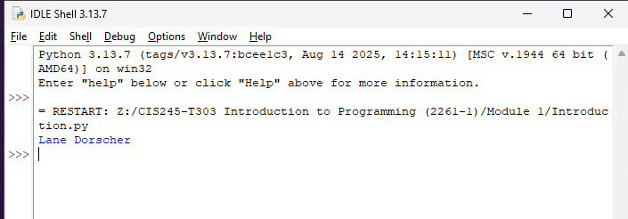

This screenshot doesn’t do a lot of justice other than showing the file explorer and IDLE shell and IDE open together on my virtual desktop 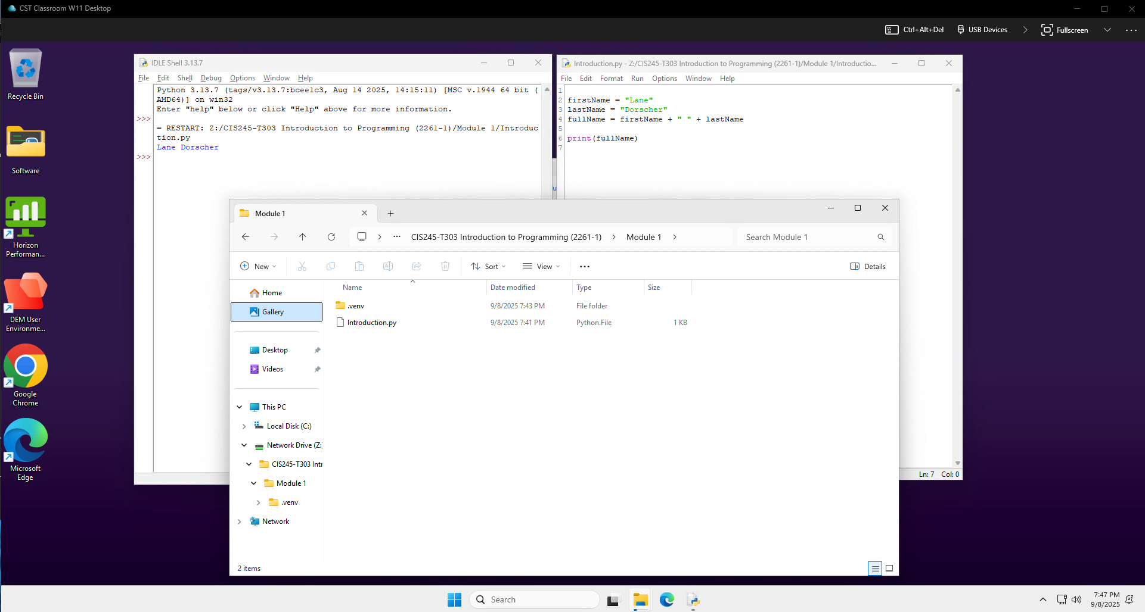
However, here is proof that my workspace is setup for network sharing with the virtual desltop.
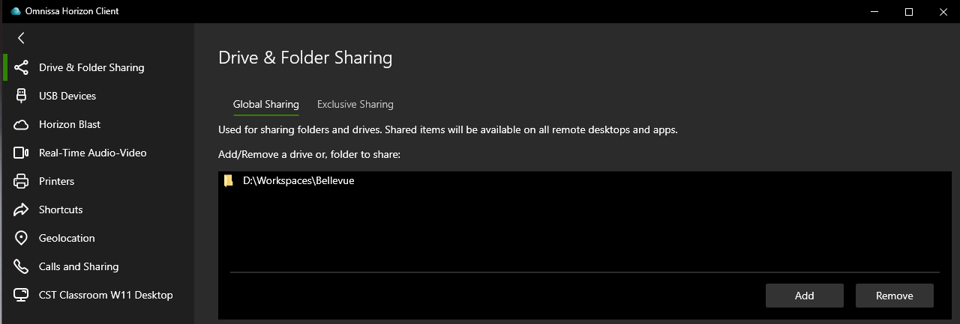

My newly created workspace with the saved program from the virtual desktop.
